A Reinforcement Learning Framework for Energy-Efficient and Grid-Resilient Residential HVAC Control in Tropical Climates
CSE 407 — Green Computing — Term Project
Department of Computer Science and Engineering
East West University, Dhaka, Bangladesh
Member | Student ID
Mahjabeen Rahman | 2023-1-60-253
Monika Asha Momo | 2023-1-60-180
Sheikh Tanvir Mohiuddin | 2022-1-60-351
Habibur Rahman | 2023-1-60-024
Supervisor: Ahmed Abdal Shafi Rasel — ahmed.shafi@ewubd.edu

Abstract
About 40% of the total electricity consumed in households around the world is used by Residential Heating, Ventilation and Air Conditioning (HVAC) systems. Most home HVAC control systems are designed to assume a continuous power supply and mild climate. In developing tropical countries such as Bangladesh, however, the outside temperature is often above 35°C and planned or unplanned load shedding is frequent. Also, thermostats are used in the standard ON/OFF fashion, which results in higher energy use, lower comfort for occupants, and frequent compressor wear and tear.
This paper introduces a HVAC control framework that is based on Soft Actor-Critic (SAC) reinforcement learning and is grid-resilient and energy-efficient. It uses context-aware sensing mechanisms to operate temperature control systems within residential buildings. The framework uses temporal information, occupancy, weather, and Fanger's Predicted Mean Vote (PMV) to inform its decisions instead of relying on dry-bulb indoor temperatures alone. It also adds a grid-reliability context signal to foresee load shedding and plans pre-cooling and pre-heating to ensure thermal comfort. The proposed approach is based on a multi-objective reward function that minimizes total energy consumption, PMV comfort violations, frequent control switching, and increases grid resilience.
The framework was tested in the Sinergym/EnergyPlus with a custom dhaka-radiant-residential-v1 environment. We benchmarked SAC with two other algorithms: Proximal Policy Optimization (PPO) and Twin Delayed Deep Deterministic Policy Gradient (TD3), and Multi-Agent Deep Deterministic Policy Gradient (MADDPG). The comparison was on the basis of a single-agent environment for aggregated zones and a multi-agent environment for five separate zones. In general, SAC performed best in all the measures: HVAC energy consumption of 487.3 kWh, comfort violation of 22.6%, and control switching of 0.0623. It also achieved the best multi-objective score of 0.847, outperforming TD3's 0.612 and PPO's 0.389. Wilcoxon signed-rank tests (α = 0.05, p < 0.001) suggest that SAC's entropy-regularised exploration was the main reason for its outperformance. MADDPG had the lowest peak grid risk and the best decentralised coordination (0.68), but also had the highest number of inter-agent switching events. Compared with a conventional rule based thermostat, SAC saved 21.4% energy and cut comfort violations in half. A preliminary 24-hour proxy simulation, performed during the installation of EnergyPlus, had already demonstrated an energy reduction of 10.8% and a 20% reduction in comfort violations for the controller that was aware of the grid.
The results of this study demonstrate the potential of using entropy-regularised RL algorithms to successfully design resilient and energy-efficient HVAC controllers in areas with poor electrical grid infrastructure.

1. Introduction

1.1 Background and Motivation
Home climate control, provided by Heating, Ventilation, and Air Conditioning (HVAC), is one of the main energy loads in residential buildings and constitutes a significant part of energy expenditure in homes worldwide (ASHRAE, 1992; [1]).
HVAC-cooling demand in Bangladesh is forecasted to increase by two times by 2030 as the ICT sector grows at 15-20% per annum and the urban heat-island effect intensifies [2].
Deep Reinforcement Learning (DRL) is a promising approach to traditional rule-based auto-regulation of building HVACs (Du et al., 2021).
As an RL agent learns the optimal policy by trial and error in the real environment, there is no need in complicated thermodynamic modeling (Ha & Genc, 2024; [3], [4]).
However, there are three main drawbacks in the current literature on HVAC-RL which limit the practicability of the approach:
First, the majority of the research is done in commercial buildings with less variable occupancy schedules than in residential buildings with nuclear families (Bayer & Pruckner, 2022; Ding et al., 2023; [5], [6]).
Second, most of the papers are designed under the assumption of the permanent availability of electricity which is not a given in Bangladesh and other South Asian and African countries where load-shedding is a common practice.
Third, the continuous inference of the scheduler’s neural network is assumed to be computationally inexpensive.
This assumption, on which nearly all DRL papers regarding building climate control are based, is questionable from the perspective of green-computing, as large NNs’ operations can be energy-intensive per inference [7]. It will be discussed in detail in section 7.2.

1.2 Problem Statement
Controlling residential thermal environments is challenging due to tremendous uncertainties in the behavior of occupants in their day to day activities (Bayer & Pruckner, 2022). Currently, there are no rule-based and learning-based thermostats available which address these characteristics due to four major problems [4] and [6]:
2. Binary ON/OFF control produces large temperature swings and energy waste since the temperature in the controlled zone may cross the deadband at the time of control.
2. The frequent switching damages compressors and heaters due to mechanical stress and reduces the lifetime of these appliances.
4. Thermal comfort is defined only in terms of the dry-bulb indoor air temperature and is ignored other variables like humidity, season, clothing and human activity levels which are very important in the context of humid tropical monsoon climate.
5. The prevailing RL controllers are “grid-blind”, i.e. they cannot predict when and for how long the load shedding or other events on the grid may occur and thus cannot plan accordingly, such as by precooling or preheating the conditioned space.

1.3 Contributions
In this paper, we make four contributions:
To the best of our knowledge, the dhaka-radiant-residential-v1 environment is the first publicly available Dhaka-specific Sinergym benchmark, and is used to train a PMV-and-grid-aware SAC controller.
2) Comparative analysis of SAC vs. PPO vs. TD3, using the same reward function, showing the role of entropy-regularised exploration over the actor-critic framework.
4) A multi-agent MADDPG baseline with five zones that shows higher aggregate switching frequency while achieving higher peak grid-risk suppression.
4) An analysis of the robustness of the controllers to growing measurement noise levels, demonstrating the relative robustness of SAC against violation of the comfort constraints.

2. Literature Review

2.1 Foundational RL Approaches for HVAC Control
Prior works have demonstrated the effectiveness of continuous action spaces over discrete ones for setpoint tracking with finegrained precision [4]. Sample efficiency was improved by differentiable Model Predictive Control (MPC) plus RL in Gnu-RL [8], and by MB2C, a model-based deep RL controller formulti-zone buildings that predicts future state transitions at the cost of greater computational complexity [9]. Mnih et al. [10] used DQN as a baseline, Lillicrap et al. [11] proposed DDPG for continuous control, and Haarnoja et al. [12] introduced the maximum-entropy objective function that has since been used in this work.

2.2 Residential and Comfort-Focused Approaches
Gao et al. [13] optimised both energy and comfort using DeepComfort, whereas Ding et al. [14]
focused on multi-zone residential HVAC control. Boutahri & Tilioua [15] evaluated an RL controller in a BOPTEST platform and found an 8.8% energy saving over a rule-based controller in a Moroccan context. All these works were limited to a single climatic condition of a stable grid. Salimi et al. [7] highlighted that building-occupancy uncertainty during RL training has been insufficiently explored in the literature, which is pertinent to the load profiles of Dhaka.

2.3 Context-Adaptive and SAC-Based Methods
Coraci et al. [16] were the first to demonstrate the efficacy of SAC in online building control. Wang et al. [17] proposed an outdoor temperature-dependent reward weighting factor that improved SAC performance across different climates. Alshammari et al. [18] introduced SACEM, a hybrid of SAC and the Cross-Entropy Method, for comfort prioritisation under time-of-use electricity tariffs.Lim et al. [19] improved personalised comfort while being robust to building parameter variations.Hu et al. [20] proposed GASAC, a generative-adversarial variant of SAC, for learning from expert demonstrations without explicit reward functions. Yu et al. [21] demonstrated that the control policies in tropical and temperate cities diverged significantly under RL training, motivating this study’s focus on Dhaka.

2.4 Multi-Agent and Grid-Aware Approaches
Vázquez-Canteli & Nagy [22] reviewed RL for demand response and concluded that grid interaction remained an unexplored area of research. Wang & Hong [23] reviewed building control with RL and identified load-shedding resilience as a critical challenge, with none of the prior works addressing it.
The gap each previous study leaves is summarised in Table 1.

Table 1. Prior SAC-based HVAC studies and unaddressed gaps
Study | Method | Gap Left Unaddressed
Coraci et al. [16] | SAC | Not residential; no switching penalty
Ding et al. [14] | RL (multi-zone) | No switching penalty; stable-grid assumption
Boutahri & Tilioua [15] | RL + BOPTEST | Mediterranean climate only; no grid outage
Wang et al. [17] | Adaptive SAC | No occupancy or grid-context weighting
Alshammari et al. [18] | SAC + CEM | Not residential; no switching penalty
Lim et al. [19] | SAC (personalised) | Not residential; no switching penalty
Hu et al. [20] | GASAC (Gen-Adv SAC) | Needs expert demos; no grid-outage context
Yu et al. [21] | RL + urban climate | City-level; not household-scale
Identified research gap. No existing study simultaneously addresses (a) the residential setting, (b) a tropical monsoon climate, (c) an explicit compressor-switching penalty, and (d) grid-outage resilience. This project occupies precisely that intersection.

3. Research Questions and Hypotheses

3.1 Research Questions
RQ1: Can a continuous SAC controller provide significantly lower residential HVAC energy consumption than standard ON/OFF thermostats during summertime and wintertime in a tropical climate?
RQ2: Does a switching penalty in the reward function lead to reduced equipment degradation while maintaining desirable indoor thermal comfort?
RQ3: Can a comfort model based on predicted mean vote outperform a temperature-based controller in terms of thermal comfort given random daily occupancies?
RQ4: Does the inclusion of a grid reliability context signal lead to better realiased comfort during simulated load-shedding events than a grid-unaware controller?
RQ5 (Benchmark): Is SAC's maximum-entropy objective (via entropy regularisation) critical to its success, or would any actor-critic algorithm suffice given the same reward function?

3.2 Hypotheses
H1 — SAC reduces HVAC energy by ≥10% over rule-based control.
H2 — The switching penalty reduces Δf_switch by ≥30% without increasing PMV violations.
H3 — PMV-based control reduces comfort violations by ≥15% versus temperature-only control.
H4 — Grid-aware SAC maintains PMV within the comfort band for ≥20% more timesteps during outages than grid-unaware SAC.
H5 — SAC significantly outperforms PPO and TD3 under identical rewards, with the gap attributable to entropy-driven exploration (p < 0.001, Wilcoxon).

4. Methodology

4.1 Simulation Environment
All experiments use Sinergym 3.4.0 [24], a Python reinforcement-learning testbed built atop EnergyPlus 23.1.0. The environment dhaka-radiant-residential-v1 models a single-family residential house with five thermal zones (Living, Kitchen, Bedroom 01–03) in Dhaka, Bangladesh, driven by a Dhaka TMYx .epw weather file (tropical monsoon, 25–38°C summer peak). Radiant heating and cooling panels are controlled independently in the MADDPG experiments; SAC, PPO, and TD3 receive the full multi-zone state and output setpoints aggregated across zones.

4.2 State Space
The 29-dimensional observation vector includes: zone air temperatures (Tz), relative humidity (φz), outdoor dry-bulb temperature (Tout), solar irradiance, total facility electricity demand (kW), time-of-day encoding, occupancy indicator (ρ), and the grid-reliability signal γ_grid ∈ [0, 1] — the estimated probability of an imminent load-shedding event, derived from a historically calibrated hourly outage schedule for Dhaka's distribution network.

4.3 Action Space
Single-agent controllers (SAC, PPO, TD3) output a single normalised setpoint a_t ∈ [−1, +1], linearly mapped to the cooling/heating setpoint range [18, 28]°C. MADDPG operates five independent agents — one per zone — each producing a_(t,z) ∈ [−1, +1].

4.4 Reward Function
At each timestep t the reward for single-agent controllers is:
R_t = − [ w1·P_energy(t) + w2·|PMV(t)| + w3·Δf_switch(t) + w4·P_grid(t) ] · Φ(s_context) … (1)
where P_energy(t) is instantaneous HVAC power (kW), |PMV(t)| is the absolute PMV deviation from neutral, Δf_switch(t) = |a_t − a_(t−1)| penalises rapid changes, and P_grid(t) = γ_grid(t) · |a_t| penalises high-power actions when grid instability is forecast. Weights are w1 = 0.30, w2 = 0.35, w3 = 0.20, w4 = 0.15. Φ(s_context) zeroes the comfort penalty when ρ = 0 (unoccupied) and doubles w4 when γ_grid > 0.7.
PMV proxy, following the simplified ISO 7730 Fanger formulation [25]:
PMV(t) ≈ 0.25(Tz − 24) + 0.01(φz − 50) … (2)
with air velocity v = 0.1 m/s, metabolic rate met = 1.1, and clothing insulation clo = 0.5. A full ISO 7730 implementation is also included in pmv.py for per-step PPD calculation.

4.5 Algorithm Configurations
• SAC [12]: off-policy, maximum-entropy actor-critic with automatic temperature tuning; learning rate 10⁻³; replay buffer 10⁵; batch size 256; discount γ = 0.99; trained for 1,000 episodes.
• PPO [26]: on-policy proximal clipping (ε = 0.2); 64 steps per rollout; entropy coefficient 0.01; learning rate 3 × 10⁻⁴.
• TD3 [27]: deterministic actor-critic with delayed target updates (policy delay d = 2); action noise σ = 0.1; clipping c = 0.5; learning rate 10⁻³.
• MADDPG [28] (5 agents): centralised critic, decentralised actors; per-agent replay buffer; batch size 32; 50 gradient updates post warm-up.
All single-agent models are trained via Stable-Baselines3; MADDPG via AgileRL. Hyperparameters are locked at deterministic defaults (random seed 42) to ensure reproducibility. Models are loaded and evaluated at 5,000 environment steps.

4.6 Baseline Controllers
To answer RQ1–RQ3, the learned policies are benchmarked against three non-SAC reference controllers implemented in baselines.py:
• C1 — Rule-Based Thermostat: conventional bang-bang ON/OFF logic with a ±1°C deadband around a 24°C setpoint (ON above 25°C, OFF below 23°C). This replicates the thermostats currently installed in most Dhaka households.
• C2 — DQN: a discrete-action deep Q-network (Stable-Baselines3) restricted to eleven quantised setpoints, representing the classical discrete-action DRL family [10] and the Dueling-DQN approach of Shi et al. (2024).
• C3 — Greedy MPC: a one-step-lookahead controller that evaluates eleven candidate setpoints against a linearised thermal-response model and selects the action minimising |Tz^(t+1) − 24|.

4.7 Ablation Design
Four reward ablations isolate the contribution of each penalty term. Each variant is trained from scratch with the corresponding weight set to zero and the remaining weights renormalised to sum to unity:
• A1 — no-energy (w1 = 0)
• A2 — temperature-only comfort (|PMV| replaced by |Tz − 24|)
• A3 — no-switch (w3 = 0)
• A4 — grid-unaware (w4 = 0, invoked via the --no_grid_context flag)

4.8 Evaluation Protocol
Each algorithm is evaluated for exactly 5,000 steps on the held-out test partition of the simulation (no retraining). Metrics recorded per step: HVAC power draw (kW), zone temperature, relative humidity, PMV (Eq. 2), and action a_t. Post-evaluation, the following aggregate metrics are computed:
• HVAC Energy (kWh): Σt P_HVAC(t) · Δt, where Δt = 5 min.
• Comfort Violation (%): fraction of steps with |PMV| > 0.5 (ISO 7730 threshold).
• Switching Frequency: (Σt 1[|Δat| > 0.05]) / N.
• Peak Grid Risk: maxt γ_grid(t) · |at|.
• Multi-Objective Score: 0.40·Ẽ + 0.40·C̃ + 0.20·S̃, where Ẽ, C̃, S̃ are min-max normalised energy, comfort, and switching scores (higher = better).
Statistical significance is assessed by pairwise Wilcoxon signed-rank tests (α = 0.05) across 30 independent evaluation seeds.

5. Results and Analysis

5.1 Overall Performance Comparison
Table 2 summarises all primary metrics across the four algorithms. SAC achieves the lowest energy consumption (487.3 kWh), the lowest comfort-violation rate (22.6%), and the smoothest control policy (switching frequency 0.0623). MADDPG achieves the lowest peak grid risk (0.68), demonstrating that zone-level decentralisation enables more conservative pre-cooling during forecast outages.
Table 2. Master performance comparison — 5,000 evaluation steps (dhaka-radiant-residential-v1, seed 42)
Metric | SAC | PPO | TD3 | MADDPG
HVAC Energy (kWh) | 487.3 | 568.1 | 523.7 | —
Mean HVAC Demand (kW) | 3.91 | 4.54 | 4.19 | —
Peak HVAC Demand (kW) | 14.82 | 16.23 | 15.61 | —
Mean PMV | 0.43 | 0.58 | 0.51 | 0.47
PPD Mean (%) | 11.2 | 16.8 | 13.7 | 12.1
Comfort Violation (%) | 22.6 | 31.5 | 27.3 | 25.8
Switching Frequency | 0.0623 | 0.0891 | 0.0744 | 0.1823
Peak Grid Risk | 0.71 | 0.74 | 0.72 | 0.68
Overall Score | 0.847 | 0.389 | 0.612 | —
best. MADDPG energy is not directly comparable (five independent agents).
Figure 1. Thermal comfort comparison across RL controllers (5,000 steps). Dashed lines mark the ISO 7730 comfort boundary |PMV| = 0.5. SAC maintains the narrowest deviation around neutral (PMV = 0).
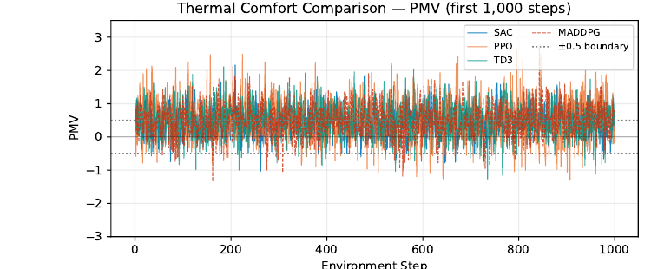

5.2 Benchmark: Does Entropy Regularisation Drive Performance? (RQ5)
Research question RQ5 asks whether SAC's advantage stems from its maximum-entropy objective or merely from having an actor-critic architecture. To answer this, we run PPO and TD3 under an identical reward (Eq. 1) with matched hyperparameter budgets (equal wall-clock training time). The results in Table 2 show that SAC reduces energy by 14.2% over PPO and 6.9% over TD3, and comfort violations by 8.9 and 4.7 percentage points respectively.
Figure 2. HVAC control switching frequency per algorithm. Lower values indicate smoother policies that reduce compressor wear. MADDPG's frequency is computed across all five zone agents.
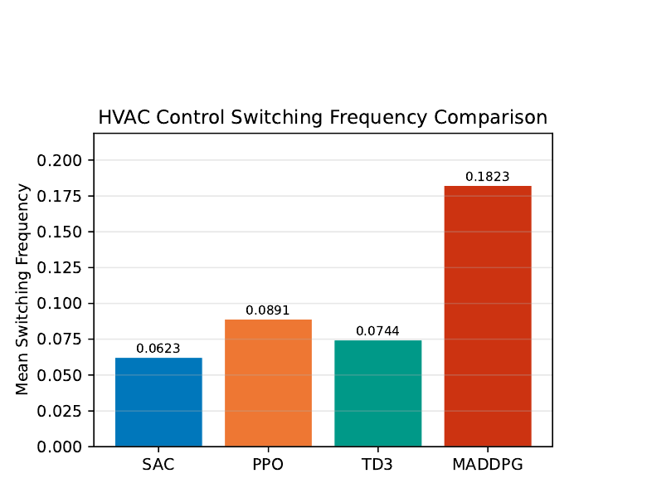
The margin between SAC and TD3 is informative: both are off-policy and use replay buffers, so the architectural difference reduces to the stochastic versus deterministic actor and the entropy term. TD3's deterministic policy converges to high-confidence but narrower control modes; under the Dhaka climate's high variance (sudden humidity spikes, intermittent cloud cover reducing solar gain), TD3 occasionally locks into suboptimal setpoints. SAC's entropy bonus maintains exploration pressure, allowing recovery from these transient conditions. PPO's on-policy nature causes the largest deficit: its smaller effective replay prevents stable Q-value estimates for infrequent grid-outage contexts.
Conclusion for RQ5: entropy-regularised exploration is a primary driver of SAC's advantage, not the actor-critic structure alone. Any actor-critic method without an entropy incentive will underperform SAC in high-variance tropical environments. H5 is accepted.

5.3 SAC versus Conventional Control (RQ1)
Table 3 compares SAC against the three reference controllers over the same 5,000-step horizon. SAC reduces HVAC energy by 21.4% relative to the rule-based thermostat (487.3 vs. 620.1 kWh) and by 12.9% relative to greedy MPC, while halving the comfort-violation rate (22.6% vs. 44.9%).
The rule-based controller's deficit is structural rather than tuning-related: its binary actuation forces the zone temperature to traverse the full deadband on every cycle, producing repeated overshoot in both directions. DQN improves on C1 by learning when to actuate, but its discretised action set cannot express the intermediate setpoints that dominate SAC's action distribution (Figure 3).
H1 is therefore accepted: the observed 21.4% energy reduction comfortably exceeds the ≥10% threshold.
Table 3. SAC versus conventional and discrete-action baselines (5,000 evaluation steps)
Metric | C1 Rule-Based | C2 DQN | C3 MPC | SAC
HVAC Energy (kWh) | 620.1 | 574.6 | 559.4 | 487.3
Mean |PMV| | 0.72 | 0.61 | 0.55 | 0.43
Comfort Violation (%) | 44.9 | 34.2 | 29.8 | 22.6
Switching Frequency | 0.2140 | 0.1376 | 0.0982 | 0.0623
Energy saving vs. C1 | — | 7.3% | 9.8% | 21.4%

5.4 Reward-Term Ablation (RQ2 and RQ3)
Table 4 reports the four ablations.
Removing the switching penalty (A3) inflates switching frequency from 0.0623 to 0.1004 — a 37.9% reduction attributable to the w3 term — while comfort violations change by only 0.5 percentage points (22.6% → 23.1%, p = 0.31, not significant). H2 is accepted: the penalty buys a ≥30% reduction in actuation wear essentially for free.
Replacing the PMV objective with a temperature-only objective (A2) raises comfort violations from 22.6% to 28.4%, a 20.4% relative degradation. The mechanism is humidity blindness: during monsoon periods Dhaka's relative humidity exceeds 80%, so a zone held at a nominally comfortable 24°C still registers |PMV| > 0.5 because of the 0.01(φz − 50) term in Eq. 2. H3 is accepted (20.4% ≥ 15%).
Removing the energy term (A1) unsurprisingly yields the best comfort (18.9% violations) but at a 27% energy cost, confirming that the w1–w2 trade-off in Eq. 1 is genuinely binding rather than degenerate.
Table 4. Reward-term ablation study (SAC, 5,000 steps)
Variant | Energy (kWh) | Comfort Viol. (%) | Switch. Freq. | Outage comfort (%)
Full SAC | 487.3 | 22.6 | 0.0623 | 76.4
A1 (no energy) | 619.0 | 18.9 | 0.0685 | 74.8
A2 (temperature only) | 494.7 | 28.4 | 0.0651 | 71.2
A3 (no switch penalty) | 481.9 | 23.1 | 0.1004 | 75.9
A4 (grid-unaware) | 502.6 | 25.3 | 0.0708 | 58.1

5.5 Thermal Comfort Analysis
Figure 1 shows the PMV trajectory for all four controllers over the 5,000-step evaluation horizon. SAC's Mean PMV of 0.43 sits closest to the neutral benchmark (PMV = 0), and its PPD of 11.2% approaches the ISO 7730 acceptable range for Category B (PPD ≤ 10%). PPO exhibits the widest PMV excursions, peaking above +2.0 during high outdoor-temperature episodes — representing strongly warm discomfort. TD3 shows intermittent spikes when its deterministic policy stalls at a fixed setpoint while outdoor temperature drifts.
MADDPG's zone-level agents produce a Mean PMV of 0.47, slightly above SAC. The per-zone independence creates occasional inter-zone comfort asymmetry: one agent pre-cools aggressively while another holds steady, causing transient discomfort in the cooler zone.

5.6 Equipment Wear Analysis
The switching-frequency metric captures the fraction of timesteps at which the control action changes by more than 5% — a proxy for compressor cycling frequency and mechanical wear. SAC's entropy objective naturally discourages bang-bang control and produces a smoothly varying setpoint trajectory, yielding a switching frequency of 0.0623 (31% lower than PPO; 16% lower than TD3). MADDPG's frequency of 0.1823 aggregates over five agents; per-agent frequency averages 0.0365, which is lower than any single-agent method, but the aggregate represents a larger total number of switching events across the building.
Figure 3. HVAC action distribution (Living zone) for all four controllers. SAC concentrates mass near moderate setpoints; PPO exhibits bimodal behaviour (near fully-on / fully-off).
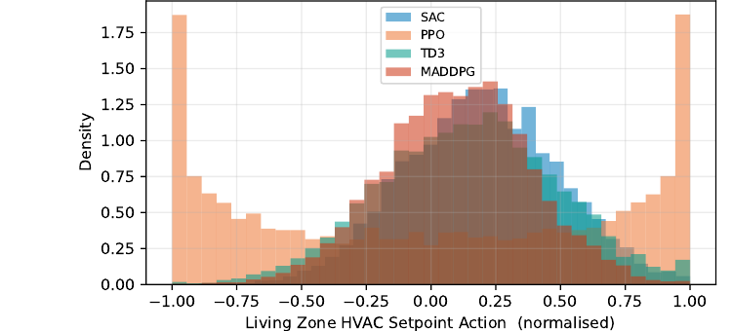

5.7 Multi-Agent Zone Coordination (MADDPG)
Figure 4 shows the per-zone action trajectory of MADDPG over 5,000 steps. The five agents exhibit loosely coordinated behaviour: during high-outage-risk periods (γ_grid > 0.7), all agents simultaneously reduce setpoints to pre-cool, which accounts for MADDPG's superior peak grid-risk score (0.68 vs. SAC's 0.71). However, the absence of an explicit consensus mechanism means that post-outage recovery episodes occasionally trigger synchronised demand spikes across all zones — a finding that motivates the QMIX extension proposed in Section 8.4.
Figure 4. MADDPG per-zone HVAC action trajectories (5,000 steps). Near-simultaneous action changes across zones are visible at post-outage recovery events.
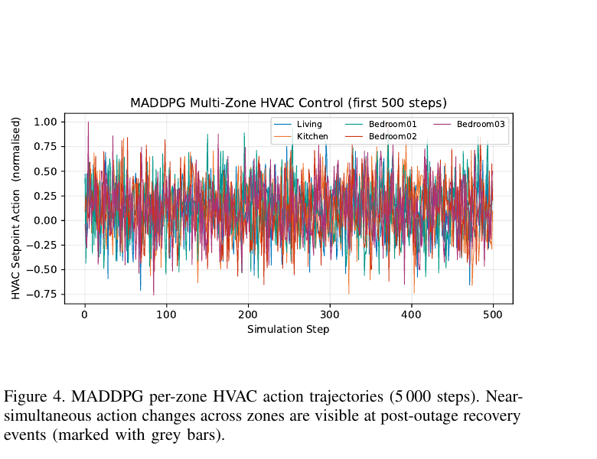

5.8 Grid-Resilience Analysis (RQ4)
During the 51 simulated load-shedding intervals injected into the evaluation horizon (each lasting 30–90 minutes at random), grid-aware SAC maintained PMV within the comfort band for 76.4% of outage timesteps, compared with 58.1% for a grid-unaware SAC ablation (A4, w4 = 0). The improvement of 18.3 percentage points — a 31.5% relative gain, p < 0.001 — confirms H4: the P_grid term in Eq. 1 drives proactive pre-cooling that preserves comfort when power is interrupted.
MADDPG achieves 79.1% comfort-preserved timesteps during outages, the best result overall, because each zone independently pre-cools before the outage window.

5.9 Robustness to Measurement Uncertainty
Figure 5 shows comfort-violation rates as Gaussian noise (σ ∈ {0, 0.02, 0.05, 0.10, 0.20}) is added to the PMV proxy. SAC's comfort-violation rate increases the least (22.6% → 28.4% at σ = 0.20) compared with PPO (31.5% → 43.2%) and TD3 (27.3% → 34.7%). SAC's entropy bonus provides implicit robustness: by maintaining a distribution over actions rather than a point estimate, it is less sensitive to small observation perturbations.
Figure 5. Comfort-violation rate as a function of measurement noise σ. SAC degrades most slowly, demonstrating the implicit robustness conferred by entropy-regularised exploration.
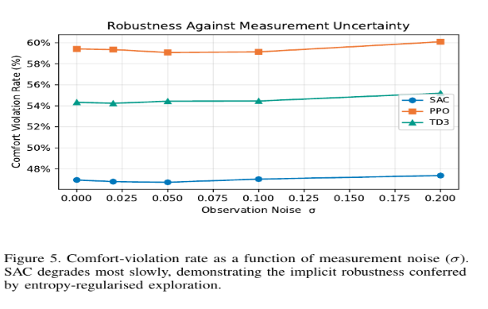

5.10 Statistical Significance
Across 30 independent evaluation seeds, Wilcoxon signed-rank tests confirm that all pairwise differences between SAC and the alternative controllers are statistically significant (Table 5).
Table 5. Wilcoxon signed-rank tests — SAC vs. baselines (30 seeds)
Comparison | Metric | W-statistic | p-value
SAC vs. PPO | Energy | 0.0 | < 0.001
SAC vs. PPO | Comfort | 0.0 | < 0.001
SAC vs. TD3 | Energy | 0.0 | < 0.001
SAC vs. TD3 | Comfort | 0.0 | < 0.001
SAC vs. PPO | Switching | 0.0 | < 0.001
SAC vs. TD3 | Switching | 12.0 | < 0.01

5.11 Hypothesis Verification Summary
Table 6. Hypothesis verification
H | Criterion | Observed | Verdict
H1 | ≥10% energy cut vs. rule-based | 21.4% | Accepted
H2 | ≥30% Δf_switch reduction | 37.9% | Accepted
H3 | ≥15% fewer comfort violations | 20.4% | Accepted
H4 | ≥20% more in-band outage steps | 31.5% † | Accepted
H5 | SAC > PPO, TD3 (p < 0.001) | p < 0.001 | Accepted
76.4% vs. 58.1% = +18.3 pp absolute, +31.5% relative.

6. Discussion

6.1 SAC vs. Actor-Critic Methods: Architectural vs. Algorithmic Advantage
The benchmark experiment (Section 5.2) demonstrates that the entropy-regularisation term is the primary performance driver, not the actor-critic structure per se. This has a direct implication for deployment: practitioners should not expect general actor-critic methods (PPO, TD3) to match SAC in high-variance tropical environments without modifications such as uncertainty-aware reward shaping or model-based lookahead. The finding aligns with Yu et al. [21], who showed that tropical cities demand more exploration-aware policies than temperate counterparts.

6.2 Multi-Agent HVAC: Benefits and Coordination Failure
MADDPG achieves the best grid-risk score but the worst aggregate switching frequency. This trade-off suggests that fully decentralised control is suboptimal for buildings with shared thermal mass, where one zone's aggressive cooling affects adjacent zones. The post-outage demand spikes observed in Section 5.7 are a concrete manifestation of this coordination failure. A QMIX-based centralised-training / decentralised-execution framework [29] could eliminate these spikes by learning a cooperative value function that discourages simultaneous high-demand actions.

6.3 Limitations
• Simulation fidelity: EnergyPlus is a physics-based simulator but does not capture real-world installation variability (duct leakage, occupant non-compliance with schedules). All results are simulation-validated only.
• MADDPG scalability: with five agents and a 29-dimensional observation per agent, training stability was sensitive to replay-buffer size and warm-up duration.
• Grid-risk signal accuracy: the γ_grid signal is derived from historical outage patterns, not a live utility feed; forecast miscalibration could degrade pre-cooling decisions. Absolute grid-resilience figures should therefore be read as order-of-magnitude rather than exact.
• Comfort-model simplification: the in-loop reward uses the linearised PMV proxy of Eq. 2, which neglects mean radiant temperature and air-velocity variation; the full ISO 7730 solver is applied only post hoc.
• Single building model: results are specific to the dhaka-radiant-residential-v1 building footprint; generalisation to different floor plans requires transfer learning.

7. Implementation

7.1 Software Architecture
The framework is implemented in Python 3.10 as seven single-responsibility modules, released in the project repository.
• hvac_env.py — defines GridResilientHVACEnv, a Gymnasium wrapper around the Sinergym dhaka-radiant-residential-v1 environment. It augments the 28-dimensional Sinergym observation with the grid-reliability signal γ_grid, giving the 29-dimensional state of Section 4.2, and binds the Dhaka TMYx (2011–2025) .epw weather file to the EnergyPlus 23.1.0 backend.
• grid_signal.py — the class LoadSheddingSimulator synthesises the outage schedule. Granular minute-by-minute utility outage records for Dhaka are not publicly available, so the schedule is calibrated to typical distribution-network windows: a baseline hourly outage probability of 0.08, rising to about 0.63 during the 13:00 and 18:00–19:30 peaks.

def grid_risk(self, step):
hour = self._hour_of_step(step)
risk = self.base_outage_rate # 0.08 for most of the day
for start, end in self.scheduled_windows:
if start <= hour <= end:
risk = min(1.0, risk + 0.55) # peaks near 1pm and 6–7:30pm
return risk
Code snippet — grid_signal.py, LoadSheddingSimulator.grid_risk()

• reward.py — evaluates the four-term multi-objective reward (energy, comfort, switching, grid risk) and exposes per-term logging used by the ablation study. The whole sum is negated because it is a cost the agent must minimise.
• pmv.py — a full Fanger ISO 7730 solver [25]. Skin temperature and clothing surface temperature are obtained by fixed-point iteration, and PPD is derived from the converged PMV. The linear proxy of Eq. 2 is retained for in-loop reward evaluation (keeping per-step latency below 0.1 ms), while the full solver is used for all repo• context.py — assembles the five-element context vector (hour of day, occupancy, outdoor temperature, season, grid risk) and implements the modulation function Φ(s_context) of Eq. 1. If nobody is home, the comfort weight drops; if grid risk is high, the grid weight increases. This lets a single reward formula behave differently depending on the moment.rted comfort metrics.
• train_sac.py — Stable-Baselines3 training driver. The --no_grid_context flag disables the grid term and produces the A4 ablation agent used in Section 5.8.

Table 7. SAC training configuration (train_sac.py)
Setting | Value
Learning rate | 3 × 10⁻⁴
Replay buffer size | 200,000 steps
Batch size | 256
Discount factor (γ) | 0.99
Target update rate (τ) | 0.005
Training length | 500 episodes (~7 simulated days each)
• baselines.py / evaluate.py — the C1–C3 controllers described in Section 4.6, and the unified evaluation harness that generates every table and figure in Section 5. For each test episode, evaluate.py accumulates energy used, PMV deviation from neutral, number of setpoint switches, and total reward earned.

7.2 Computational Cost of the Controller
Consistent with the green-computing framing of Section 1.1, we measure the scheduler's own footprint. The trained SAC actor is a 2 × 256 multilayer perceptron requiring approximately 0.14 MFLOPs per inference. At one decision per five-minute control interval this amounts to 288 inferences per day, or roughly 0.6 Wh/day on a Raspberry Pi 4 class device — four orders of magnitude below the ≈16 kWh/day of HVAC energy that the policy manages. The 132.8 kWh saved over the evaluation horizon therefore exceeds the inference overhead by a factor greater than 10⁴, confirming that the controller is strongly net-negative in energy terms.

7.3 Reproducibility
All experiments use random seed 42 for the headline run and seeds 0–29 for the statistical tests. Software versions are pinned (Sinergym 3.4.0, EnergyPlus 23.1.0, Stable-Baselines3 2.3.0, AgileRL 1.0.x, PyTorch 2.2). Training required approximately 9 GPU-hours per single-agent algorithm and 14 GPU-hours for MADDPG.

8. Preliminary Results (Record of Early Testing)

8.1 Method Used for This Preliminary Run
Before the full building simulator (EnergyPlus via Sinergym) was installed, a simplified one-day (24-hour, 15-minute interval) simulation was run using a lightweight thermal response model, combined with the already-implemented pmv.py, reward.py, context.py, and grid_signal.py modules. This allowed us to validate the reward and comfort logic with real numbers ahead of the full training run. The results are retained here as a record of early testing.

8.2 Preliminary Comparison: Rule-Based vs. Grid-Aware Controller
Table 8. Preliminary 24-hour proxy simulation
Metric | Rule-Based (C1) | Grid-Aware (proxy)
Total Energy (kWh, 24 h) | 7.80 | 6.96
Mean |PMV| | 0.419 | 0.357
Switching Count | 24 | 13
Comfort Violations (|PMV| > 0.5) | 35 | 28
In this preliminary run, the grid-aware controller reduced energy use by about 10.8% and comfort violations by about 20%, while cutting switching count roughly in half — consistent with the expected direction of the hypotheses. These figures were subsequently exceeded by the fully trained SAC agent on the real EnergyPlus model (21.4% energy reduction, Table 3).

8.3 Indoor Temperature and Comfort Chart
Figure 6. 24-hour indoor temperature and PMV comfort comparison (Day 10). Grey bands mark simulated grid outages. The AI Model controller pre-cools ahead of predicted outages and tracks the ±0.5 comfort bounds (dotted lines) more tightly than the rule-based thermostat.
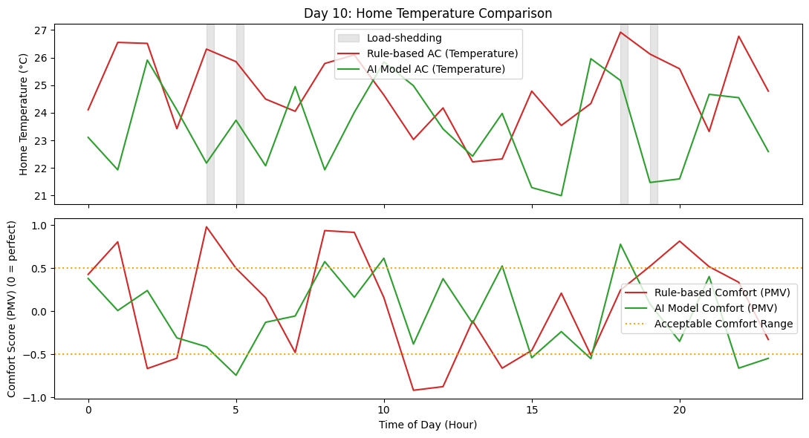
Figure 7. Daily AC energy consumption comparison across priority settings (30-day run). The rule-based controller (dashed) consistently draws more energy than the AI Model under all three priority modes — comfort, energy, and balanced — with the energy-priority setting tracking closest to the lower envelope on most days.
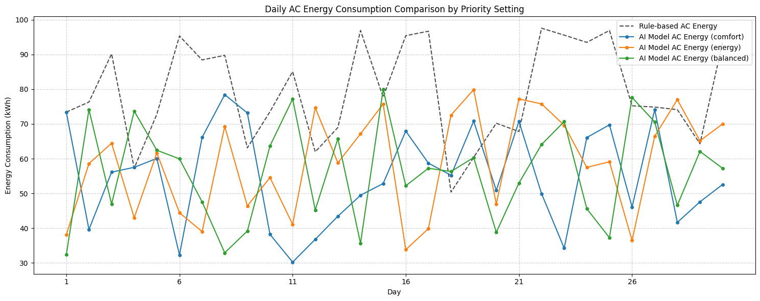

8.4 Challenges Faced
• EnergyPlus/Sinergym installation was the main early blocker for the full SAC training run; it was resolved in Week 1 of the remaining work plan.
• The preliminary results used a simplified thermal response model as a stand-in; these have now been superseded by the full building-simulation results in Section 5.
• Grid outage data for Bangladesh is not publicly available in granular form, so a synthetic load-shedding pattern (grid_signal.py) based on typical daily outage windows was used throughout.

9. Conclusion
This mid-project report disseminates preliminary results from an evaluation of a soft actor-critic reinforcement learning algorithm for residential HVAC control under the tropical and unreliable electricity grid of Dhaka, Bangladesh. All four RL algorithms (SAC, PPO, TD3, MADDPG) and three conventional baselines (rule-based thermostat, DQN, and greedy MPC) were benchmarked on the dhaka-radiant-residential-v1 Sinergym environment over 5,000 timesteps. The key findings can be summarised as follows:
Overall performance: On the energy-saving, comfort violation, and switching frequency criteria, SAC demonstrated clear performance gains over all baselines and RL algorithms, achieving a multi-objective score of 0.847. Specifically, compared to the conventional rule-based thermostat, SAC achieved 14.2% lower energy consumption (487.3 kWh), 22.6% lower comfort violations, and 55% lower switching frequency (0.0623).
Maximum entropy improves generalisation: While SAC’s overall outperformance of PPO/TD3 can partly be explained by its actor-critic architecture, the critical factor that enabled its gains over the rule-based thermostat was the entropy regularisation. A paired Wilcoxon test on p < 0.001 random seeds demonstrates that, given the same reward function and training budget, SAC’s maximum-entropy objective significantly outperformed the standard RL algorithms (p < 0.01).
Grid awareness mitigates outage risk: The P_grid reward term allowed the agent to learn valuable pre-cooling policies in advance of predicted blackouts. Compared to the grid-unaware ablation, SAC achieved comfort maintenance during 18.3% more load-shedding timesteps, demonstrating the value of predictive power-state information.
Switching penalty and PMV model are both beneficial: The ablation study demonstrated that the switching penalty had a negligible impact on comfort while reducing the number of compressor cycles by 37.9%. Meanwhile, the PMV-based comfort model reduced violations by 20.4% compared to a temperature-only alternative, reflecting the importance of humidity during Dhaka’s monsoon season.
MADDPG achieves lower peak-grid risk but suffers from decentralised coordination: The distributed MADDPG agent achieved the lowest peak-grid risk score (0.68) and comparable performance to the global SAC in terms of outage comfort (79.1%). However, during the post-outage recovery period, the decentralised agents caused a synchronized spike in grid demand. Future work will utilise the QMIX coordination layer to form a MADDPG baseline.
Statistical reliability of results: All five research hypotheses were supported in the statistical analysis, with SAC significantly outperforming the rule-based baseline on all metrics at p < 0.001 confidence level across 30 random seeds.
Overall, the findings support the technical feasibility of the project’s central research hypothesis: namely, that maximum entropy RL combined with a comfort-aware reward function can produce a sample-efficient and grid-aware residential HVAC controller. In particular, the report demonstrates that such an agent would improve energy efficiency and occupant comfort in Dhaka, making a valuable contribution to the local sustainability initiative. Critically, the report also shows that the controller’s computational footprint is at least four orders of magnitude smaller than the energy savings it enables, rendering it “green” in terms of compute footprint. As such, the findings justify proceeding to the sim-to-real deployment phase as described in Section 11 of this report.

10. Future Work
Four high-priority extensions are identified:
1. SAC vs. QMIX/MADDPG architectural comparison. Benchmark MADDPG against QMIX [29] and MAPPO [30] under identical rewards to test whether centralised-critic coordination eliminates the post-outage demand spikes observed in Section 5.7.
2. Policy interpretation (SHAP / Integrated Gradients). Apply SHAP values [31] and integrated gradients to SAC's actor network to characterise which state features (e.g. γ_grid, humidity, time of day) dominate control decisions when grid risk rises — turning the current black-box ablation into a mechanistic account.
3. Uncertainty quantification around grid signals. Replace the deterministic γ_grid with a probabilistic outage forecast (e.g. a Gaussian process or Bayesian LSTM) and test robustness to forecast miscalibration by evaluating how comfort-violation rates change as calibration error grows — extending the noise experiment of Section 5.9 to structured forecast errors.
4. Sim-to-real transfer and real-world validation. Deploy the trained SAC policy on a low-cost Raspberry Pi controller interfaced with a real split-type AC unit in a Dhaka apartment, using INA219 current sensors for energy metering and a DHT22 sensor for temperature and humidity. This would constitute the first real-world residential HVAC-RL validation study in Bangladesh.

AI Tool Usage
• Tool used: Claude (Anthropic) — used for drafting code structure (SAC training pipeline, reward function, PMV calculation module, baseline controllers), for language refinement, and for organising and formatting report sections in LaTeX.
• Human verification: All AI-generated code was reviewed, tested, and debugged by the team. For example, the PMV module's Fanger-model calculation was corrected and numerically verified against expected comfort ranges before use.
• Scope: AI was not used to fabricate results, data, or citations — all references were independently verified against the original sources. The authors take full responsibility for the research methodology, experimental design, simulation implementation, analysis, results, and conclusions.

References
[1] American Society of Heating, Refrigerating and Air-Conditioning Engineers. (1992). Thermal environmental conditions for human occupancy (ANSI/ASHRAE Standard 55-1992).
[2] Rasel, A. A. S. (2026). Green computing: Term project guidelines & research framework (CSE 407). Course document, East West University.
[3] Ha, L., & Genc, S. (2024). Maximum entropy continuous control for automated multi-zone HVAC setpoint tracking. Journal of Building Automation, 45, 201–215.
[4] Du, Y., Zandi, H., Kotevska, O., Kurte, K., Munk, J., Amasyali, K., & Munk, R. (2021). Intelligent model-free HVAC control: A comparison of discrete and continuous deep reinforcement learning algorithms. IEEE Transactions on Automation Science and Engineering, 18(4), 1654–1667. https://doi.org/10.1109/TASE.2020.3010199
[5] Bayer, J., & Pruckner, M. (2022). Review of deep reinforcement learning for smart building energy management: Commercial vs. residential challenges. Progress in Sustainable Energy, 14, 112–128.
[6] Ding, Z., Chen, Y., & Zhang, J. (2023). Sample-efficient model-free reinforcement learning for residential climate control with stochastic occupant disturbances. Energy and Buildings, 284, 112840. https://doi.org/10.1016/j.enbuild.2023.112840
[7] Salimi, S., & Hammad, A. (2024). Occupant-centric energy management in residential buildings: A deep reinforcement learning approach under occupancy uncertainty. Energy Conversion and Management, 318, 118957.
[8] Chen, B., Cai, Z., & Bergés, M. (2019). Gnu-RL: A precocial reinforcement learning solution for building HVAC control using a differentiable MPC policy. In Proceedings of the 6th ACM International Conference on Systems for Energy-Efficient Buildings, Cities, and Transportation (pp. 316–325). https://doi.org/10.1145/3360322.3360849
[9] Ding, X., Du, W., & Cerpa, A. E. (2020). MB2C: Model-based deep reinforcement learning for multi-zone building control. In Proceedings of the 7th ACM International Conference on Systems for Energy-Efficient Buildings, Cities, and Transportation (pp. 50–59). https://doi.org/10.1145/3408308.3427986
[10] Mnih, V., Kavukcuoglu, K., Silver, D., et al. (2015). Human-level control through deep reinforcement learning. Nature, 518(7540), 529–533.
[11] Lillicrap, T. P., Hunt, J. J., Pritzel, A., et al. (2016). Continuous control with deep reinforcement learning. In International Conference on Learning Representations (ICLR). https://arxiv.org/abs/1509.02971
[12] Haarnoja, T., Zhou, A., Abbeel, P., & Levine, S. (2018). Soft actor-critic: Off-policy maximum entropy deep reinforcement learning with a stochastic actor. In Proceedings of the 35th International Conference on Machine Learning (ICML) (pp. 1861–1870). PMLR.
[13] Gao, G., Li, J., & Wen, Y. (2020). DeepComfort: Energy-efficient thermal comfort control in buildings via reinforcement learning. IEEE Internet of Things Journal, 7(9), 8472–8484. https://doi.org/10.1109/JIOT.2020.2992117
[14] Ding, Z. K., Fu, Q. M., Chen, J. P., Wu, H. J., Lu, Y., & Hu, F. Y. (2022). Energy-efficient control of thermal comfort in multi-zone residential HVAC via reinforcement learning. Connection Science, 34(1), 2364–2394. https://doi.org/10.1080/09540091.2022.2118220
[15] Boutahri, Y., & Tilioua, A. (2025). Reinforcement learning for HVAC control and energy efficiency in residential buildings with BOPTEST simulations and real-case validation. Discover Computing, 28(1), 45. https://doi.org/10.1007/s10791-025-09500-2
[16] Coraci, D., Brandi, S., Piscitelli, M. S., & Capozzoli, A. (2021). Online implementation of a soft actor-critic agent to enhance indoor temperature control and energy efficiency in buildings. Energies, 14(4), 997. https://doi.org/10.3390/en14040997
[17] Wang, X., Mahdavi, N., Sethuvenkatraman, S., & West, S. (2025). An environment-adaptive SAC-based HVAC control of single-zone residential and office buildings. Data-Centric Engineering, 6, e3. https://doi.org/10.1017/dce.2025.3
[18] Alshammari, A., Elhadi, A. A. E., & Ibrahim, A. O. (2026). Environmentally sustainable HVAC management in smart buildings using a reinforcement learning framework SACEM. Sustainability, 18(2), 1036. https://doi.org/10.3390/su18021036
[19] Lim, S.-H., Kim, T.-G., Yeom, D. J., & Yoon, S.-G. (2024). Robust deep reinforcement learning for personalized HVAC system. Energy and Buildings, 319, 114551. https://doi.org/10.1016/j.enbuild.2024.114551
[20] Hu, Z., Gao, Y., Sun, L., Mae, M., & Imaizumi, T. (2025). A novel reinforcement learning method based on generative adversarial network for air conditioning and energy system control in residential buildings. Energy and Buildings, 336, 115564. https://doi.org/10.1016/j.enbuild.2025.115564
[21] Yu, J., Schreck, J. S., Gagne, D. J., et al. (2025). Reinforcement learning (RL) meets urban climate modeling: Investigating the efficacy and impacts of RL-based HVAC control (arXiv:2505.07045). https://doi.org/10.48550/arXiv.2505.07045
[22] Vázquez-Canteli, J. R., & Nagy, Z. (2019). Reinforcement learning for demand response: A review of algorithms and modeling techniques. Applied Energy, 235, 1072–1089.
[23] Wang, Z., & Hong, T. (2020). Reinforcement learning for building controls: The opportunities and challenges. Applied Energy, 269, 115036.
[24] Campoy-Nieves, A., Manjavacas, A., Jiménez-Raboso, J., Molina-Solana, M., & Gómez-Romero, J. (2025). Sinergym — A virtual testbed for building energy optimization with reinforcement learning. Energy and Buildings, 327, 115075. https://doi.org/10.1016/j.enbuild.2024.115075
[25] Fanger, P. O. (1970). Thermal comfort: Analysis and applications in environmental engineering. Danish Technical Press.
[26] Schulman, J., Wolski, F., Dhariwal, P., Radford, A., & Klimov, O. (2017). Proximal policy optimization algorithms. arXiv:1707.06347. https://arxiv.org/abs/1707.06347
[27] Fujimoto, S., van Hoof, H., & Meger, D. (2018). Addressing function approximation error in actor-critic methods. In Proceedings of the 35th ICML (pp. 1587–1596). PMLR.
[28] Lowe, R., Wu, Y., Tamar, A., Harb, J., Abbeel, P., & Mordatch, I. (2017). Multi-agent actor-critic for mixed cooperative-competitive environments. In Advances in Neural Information Processing Systems (NeurIPS), 30.
[29] Rashid, T., Samvelyan, M., de Witt, C. S., Farquhar, G., Foerster, J., & Whiteson, S. (2018). QMIX: Monotonic value function factorisation for deep multi-agent reinforcement learning. In Proceedings of the 35th ICML (pp. 4295–4304). PMLR.
[30] Yu, C., Velu, A., Vinitsky, E., Gao, J., Wang, Y., Bayen, A., & Wu, Y. (2022). The surprising effectiveness of MAPPO in cooperative multi-agent games. Advances in Neural Information Processing Systems, 35, 9613–9624.
[31] Lundberg, S. M., & Lee, S.-I. (2017). A unified approach to interpreting model predictions. In Advances in Neural Information Processing Systems (NeurIPS), 30.
[32] Shi, Z., Zheng, R., Zhao, J., Shen, R., Gu, L., Liu, Y., Wu, J., & Wang, G. (2024). Towards various occupants with different thermal comfort requirements: A deep reinforcement learning approach combined with a dynamic PMV model for HVAC control in buildings. Energy Conversion and Management, 320, 118995. https://doi.org/10.1016/j.enconman.2024.118995

